Part A
Name:- Parva Gaglani
Roll No:- C172
Subject:- Data Structures and Algorithms
Program: B Tech/MBA Tech CE 2nd Year/BTI, VII sem
Aim:
To Implement and understand the working of Insertion Sort, Selection sort and Merge sort
Prerequisite: C++ Programming
Outcome: Implementation of the Insertion Sort, Selection sort and Merge sort algorithm.
- Theory:
Sorting is the process of arranging data in a specific order, typically in ascending or descending order. This is crucial for efficient data retrieval and organization. The working principles of three common sorting algorithms: Insertion Sort, Selection Sort, and Merge Sort is given here using simple examples.
Algorithms:

- Algorithm for Insertion sort
Insertion Sort works by building a sorted array one element at a time. It iteratively takes each element from the unsorted portion and inserts it into its correct position within the sorted portion.
for i = 1 to length(A) - 1
key = A[i]
j = i - 1
while j >= 0 and A[j] > key
A[j + 1] = A[j]
j = j - 1
A[j + 1] = key

- Algorithm for Selection Sort
Selection Sort repeatedly selects the smallest (or largest) element from the unsorted portion and moves it to the sorted portion.
SelectionSort(A, n)
  - For i = 0 to n-1:
    - Assume the minimum element is the first element of the unsorted part: minIndex = i
    - For j = i+1 to n:
      - If A[j] < A[minIndex], update minIndex = j
    - Swap the found minimum element with the first element of the unsorted part

- Algorithm for Merge Sort

Merge Sort is a divide-and-conquer algorithm that splits the array into halves, recursively sorts each half, and then merges the sorted halves back together.
MergeSort(A, left, right)
  - If left < right:
    - Find the middle point to divide the array into two halves: mid = (left + right) / 2
    - Call MergeSort(A, left, mid) to sort the first half
    - Call MergeSort(A, mid + 1, right) to sort the second half
    - Call Merge(A, left, mid, right) to merge the two halves
Merge(A, left, mid, right)
  - Create temporary arrays L and R to hold the two halves
  - Copy data to temporary arrays L and R
  - Merge the temporary arrays back into A[left...right]
  - While both subarrays have elements:
    - Compare the elements and copy the smaller element to the original array
  - Copy any remaining elements of L and R to the original array

Procedure:
- Open CodeBlock editor or visual studio editor and write the code in C++.
- Complile and run the code
Instructions:

- Copy code & paste in code section and output of Part B.

Part B
Code:

#include <iostream>
using namespace std;

void insertionSort(int arr[], int n)
{
int steps = 0;
for (int i = 1; i < n; i++)
{
int key = arr[i];
int j = i - 1;
while (j >= 0 && arr[j] > key)
{
arr[j + 1] = arr[j];
j--;
steps++;
}
arr[j + 1] = key;
steps++;
}

cout << "\nSorted Array (Insertion Sort): ";
for (int i = 0; i < n; i++)
cout << arr[i] << " ";
cout << "\nTotal Steps: " << steps << "\n";
}

void selectionSort(int arr[], int n)
{
int steps = 0;
for (int i = 0; i < n - 1; i++)
{
int minIndex = i;
for (int j = i + 1; j < n; j++)
{
steps++;
if (arr[j] < arr[minIndex])
minIndex = j;
}
int temp = arr[i];
arr[i] = arr[minIndex];
arr[minIndex] = temp;
}

cout << "\nSorted Array (Selection Sort): ";
for (int i = 0; i < n; i++)
cout << arr[i] << " ";
cout << "\nTotal Steps: " << steps << "\n";
}

void merge(int arr[], int l, int m, int r, int &steps)
{
int n1 = m - l + 1;
int n2 = r - m;

int L[n1], R[n2];

for (int i = 0; i < n1; i++)
L[i] = arr[l + i];
for (int j = 0; j < n2; j++)
R[j] = arr[m + 1 + j];

int i = 0, j = 0, k = l;

while (i < n1 && j < n2)
{
steps++;
if (L[i] <= R[j])
{
arr[k] = L[i];
i++;
}
else
{
arr[k] = R[j];
j++;
}
k++;
}

while (i < n1)
{
arr[k] = L[i];
i++;
k++;
steps++;
}

while (j < n2)
{
arr[k] = R[j];
j++;
k++;
steps++;
}
}

void mergeSort(int arr[], int l, int r, int &steps)
{
if (l < r)
{
int m = l + (r - l) / 2;
mergeSort(arr, l, m, steps);
mergeSort(arr, m + 1, r, steps);
merge(arr, l, m, r, steps);
}
}

void performMergeSort(int arr[], int n)
{
int steps = 0;
mergeSort(arr, 0, n - 1, steps);

cout << "\nSorted Array (Merge Sort): ";
for (int i = 0; i < n; i++)
cout << arr[i] << " ";
cout << "\nTotal Steps: " << steps << "\n";
}

int main()
{
int choice;
int ori_arr[] = {15, 12, 67, 23, 56, 89};
int n = sizeof(ori_arr) / sizeof(ori_arr[0]);

while (true)
{
cout << "\nCurrent Order: \n";
for(int i=0; i<n; i++){cout<<ori_arr[i]<<" ";}
cout << "\nChoose Sorting Method:\n";
cout << "1. Insertion Sort\n";
cout << "2. Selection Sort\n";
cout << "3. Merge Sort\n";
cout << "4. Exit\n";
cout << "Enter your choice: ";
cin >> choice;

int arr1[n];
for (int i = 0; i < n; i++) arr1[i] = ori_arr[i]; // reset array

switch (choice)
{
case 1:
insertionSort(arr1, n);
break;

case 2:
selectionSort(arr1, n);
break;

case 3:
performMergeSort(arr1, n);
break;

case 4:
cout << "Exiting...\n";
return 0;

default:
cout << "Invalid choice! Please enter 1, 2, 3, or 4.\n";
}
}
}

Output:
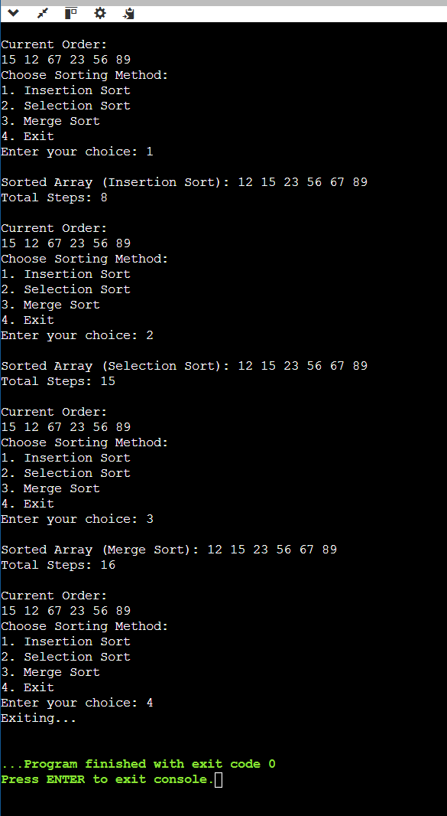

Observation & Learning:
Insertion sort is shifting all unsorted elements and inserting the required element in the current position within the sorted section

Selection sort is picking the smallest element from the unsorted part and swapping it with the current element

Merge sort is dividing into two contniously (recursive splitting) and swapping positions to sort them, then merging sorted sublists back togethar
Curiosity questions:
- Compute the number of comparisons to sort the given data sets using
- Insertion sort
- Selection Sort
- Merge Sort

Numbers: 15, 12, 67, 23, 56, 89.

Solutions:
For the array [15, 12, 67, 23, 56, 89]:
- Insertion Sort: 7 comparisons
- Selection Sort: 15 comparisons (always 6×52\frac{6 \times 5}{2}26×5​)
- Merge Sort: About 13–16 comparisons (around 6×log⁡266 \times \log_2 66×log2​6)

Conclusion:
We successfully implemented sorting algorithms using C++ program.

